Bulk Project Update

In which we can move bulk of project to updation cycle.
Page: transferProject.php
Auth name: bulk project update(gacl)
Data come from following field
-City
-resi_project
-

In which we can search project with following parameter.
1.city
2. builder
3.launch/pre-launch.
4.housing authorty
5.phase.
6.Updation cycle.
7.skip B2B.
8.Is smooth
9.stage
10.Residential
11.Project type
12.Resale project
13.Availibility
14.Active.
15 Project status.
16.Expected supply.
17.project name.

Search result come according to project_phase and project_stage.

In which we can move bulk of project to updation cycle and also edit is_smoothed field.

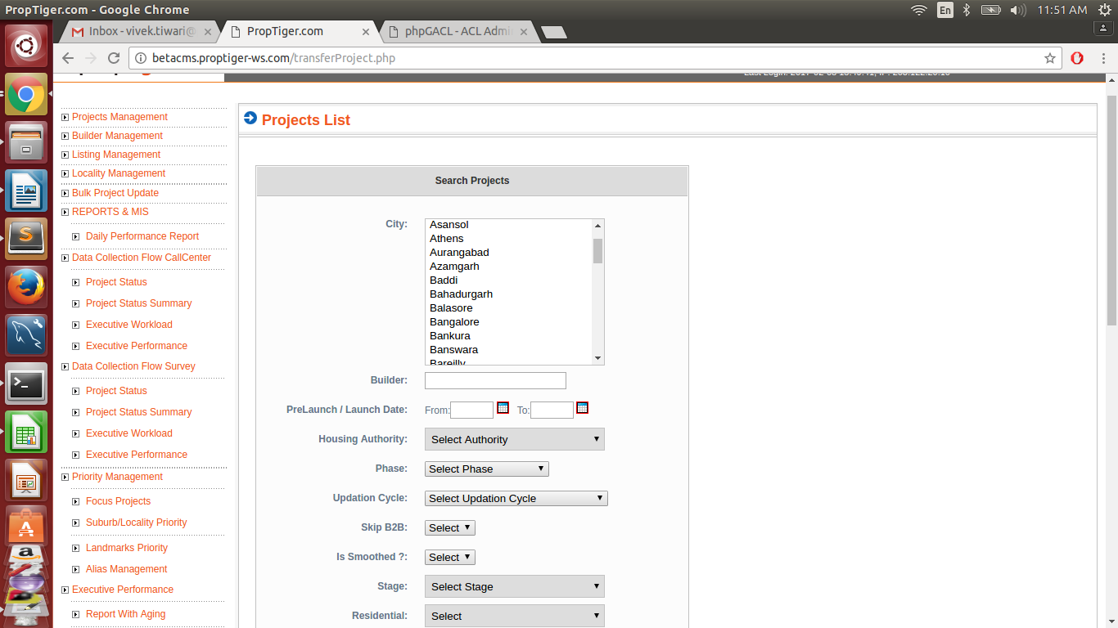

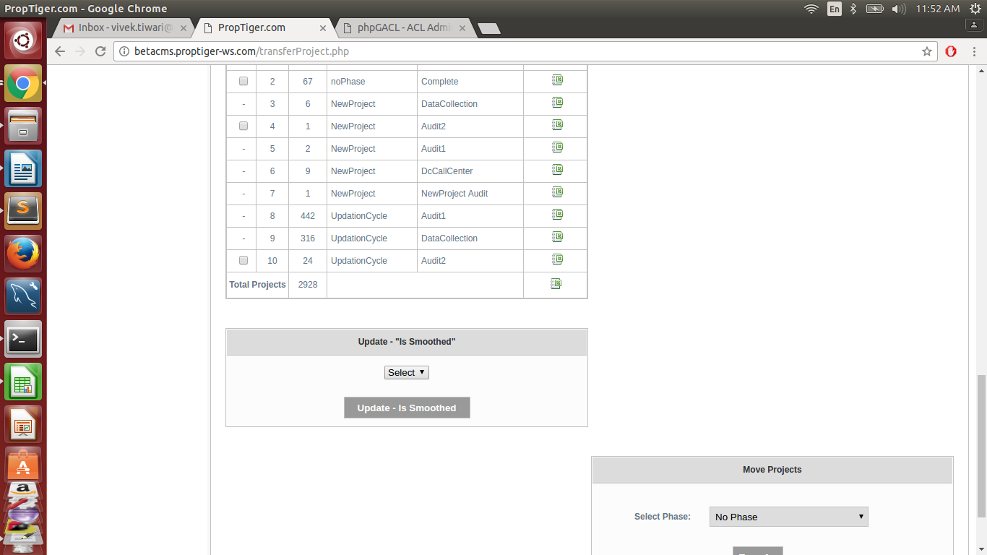

Query that fetch data for operation:

Select DISTINCT p.PROJECT_ID,p.PROJECT_PHASE_ID,p.PROJECT_STAGE_ID,ph.name as PROJECT_PHASE,
st.name as PROJECT_STAGE
FROM " . RESI_PROJECT . " p
left join master_project_phases ph on p.project_phase_id = ph.id
left join master_project_stages st on p.project_stage_id = st.id
left join locality on p.locality_id = locality.locality_id ".whereLocalitySrc("locality", "AND")."
INNER join suburb on locality.suburb_id = suburb.suburb_id
left join city on suburb.city_id = city.city_id
left join table_attributes ta on ta.table_id=p.project_id and ta.table_name='resi_project' and ta.attribute_name='HOUSING_AUTHORITY_ID'
left join table_attributes taResale on taResale.table_id=p.project_id and taResale.table_name='resi_project' and taResale.attribute_name='is_resale_project'
INNER JOIN resi_project_phase rpp on p.PROJECT_ID = rpp.PROJECT_ID";

Select COUNT(DISTINCT p.PROJECT_ID) CNT,p.PROJECT_PHASE_ID,p.PROJECT_STAGE_ID,
ph.name as PROJECT_PHASE, st.name as PROJECT_STAGE
FROM " . RESI_PROJECT . " p
left join master_project_phases ph on p.project_phase_id = ph.id
left join master_project_stages st on p.project_stage_id = st.id
left join locality on p.locality_id = locality.locality_id ".whereLocalitySrc("locality", "AND")."
INNER join suburb on locality.suburb_id = suburb.suburb_id
left join city on suburb.city_id = city.city_id
left join table_attributes ta on ta.table_id=p.project_id and ta.table_name='resi_project' and ta.attribute_name='HOUSING_AUTHORITY_ID'
left join table_attributes taResale on taResale.table_id=p.project_id and taResale.table_name='resi_project' and taResale.attribute_name='is_resale_project'
INNER JOIN resi_project_phase rpp on p.PROJECT_ID = rpp.PROJECT_ID";

